- Project Processes

- 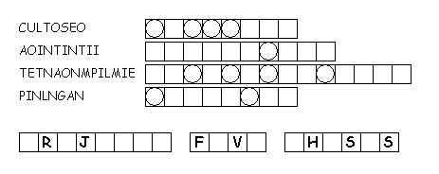

- Unscramble each of the clue words. Take the letters that appear in boxes and unscramble them for the final message.

- Created by Puzzlemaker at
- DiscoveryEducation.com

